Timothy Johnson  
September 16th, 2025  
CS499  
Professor Conlan

Milestone Two  
Enhancement One: Software Design and Engineering

For my Software Design and Engineering enhancement, I selected my CS 360 Inventory Management App, originally created in Android Studio using Java and SQLite. The app allows users to add, edit, delete, and view inventory items. Each item is stored with details such as color, quantity, and date added. I adapted the app to manage 3D printing filament, making it practical beyond the original class project. I chose this artifact because it reflects a variety of software development skills that are relevant to professional computing and my personal experience:

(OLD VS NEW)

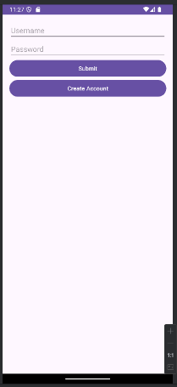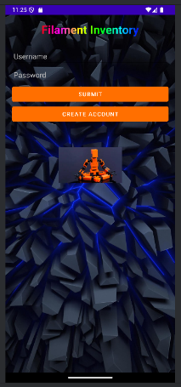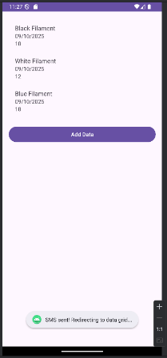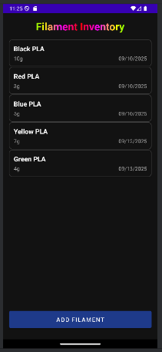

Enhancements:

* Created a Filament class to store color, quantity, and date, improving data organization and code readability.
* Switched from a grid layout to a list layout for better readability.
* Adjusted font sizes, spacing, alignment, and dark theme colors for a cleaner, professional look.
* Added a rainbow-colored title to make the app visually distinctive.
* Added a filament spool icon to match the app’s theme.
* Placed a small image at the bottom of the screen to enhance visual appeal.
* Implemented CRUD operations (add, edit, delete) with an SQLite database.
* Added input validation to prevent invalid entries, such as negative filament quantities.
* Added user feedback messages for successful or failed actions.
* Adapted a class project to a real-world scenario, tracking 3D printing filament efficiently.

I have made progress in several outcomes:

* Outcome 3: I designed and evaluated computing solutions by switching from a grid to a list layout, creating the Filament class, and implementing CRUD operations efficiently.
* Outcome 4: I demonstrated the ability to use innovative techniques and tools, including Java, Android Studio, and SQLite, while adding personalization features like the filament spool icon and rainbow title.
* Outcome 2: I improved professional-quality visual communications by refining layouts, buttons, and menus for clarity and consistency.
* Outcome 5: I took initial steps toward building a security mindset by implementing input validation and ensuring safe user interactions.

Enhancement Process and Reflection

Enhancing the app taught me a lot about balancing usability, functionality, and aesthetics. Switching from a grid to a list required updating both the XML layout files and the adapter logic, which improved my understanding of Android development. Creating the Filament class helped me organize data effectively and made adding features easier.

Adding UI personalization, such as the rainbow title and bottom image, improved the app’s appearance but required careful adjustments to keep a professional, consistent look across all screens. Input validation and user feedback were small but crucial improvements for reliable and user-friendly software.

The main challenges were iterating on the UI to maintain alignment and readability while adding personalized features and ensuring the app remained functional and intuitive. Overall, I’m proud of the polished result and feel it effectively demonstrates my skills in software design and engineering.